Additional file 1

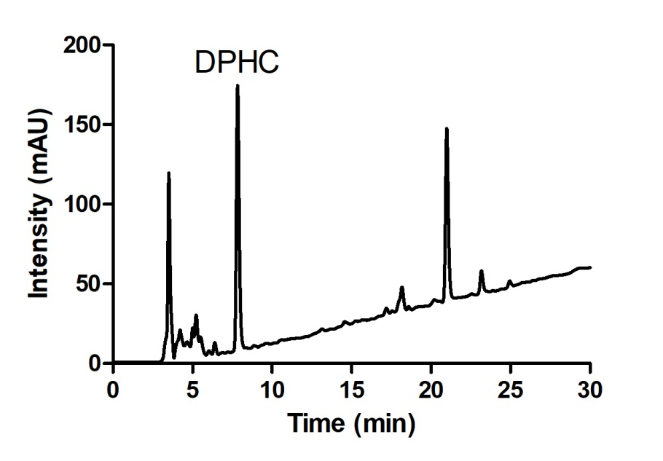

Figure A1. HPLC chromatogram of DPHC from IOE.

