Table S1. Percentage of identity similarity values of AcLysC with orthologs
Species | NCBI-GenBank accession no. | Definition | Taxonomy | Identity (%) | Similarity (%)
Amphiprion ocellaris | XP_023119752 | Lysozyme C | Fish | 98.6 | 98.6
Paralichthys olivaceus | XP_019959997 | Lysozyme C | Fish | 72 | 83.2
Anas platyrhynchos | XP_005008937 | Lysozyme C | Fish | 52.4 | 61.9
Danio rerio | AAK85299 | Lysozyme C | Fish | 37 | 55.2
Capra hircus | AGT17844 | Lysozyme C | Mammalia | 52.7 | 70.9
Homo sapiens | NP_000230 | Lysozyme C precursor | Mammalia | 58.8 | 72.3
Gallus gallus | NP_990612 | Lysozyme C precursor | Aves | 52.4 | 67.3
Python bivittatus | XP_025024095 | Lysozyme C | Reptilia | 40.5 | 58.8

Table S2. Percentage of identity similarity values of AcLysG-like with orthologs.
Species | NCBI-GenBank accession no. | Definition | Taxonomy |  | Identity (%) | Similarity (%)
Amphiprion ocellaris | XP_023119460 | Lysozyme g-like |  | Fish | 84.6 | 88.2
Perca flavescens | XP_028461465.1 | Lysozyme g-like |  | Fish | 83.1 | 90.5
Sebastes umbrosus | XP_037619887 | Lysozyme g-like |  | Fish | 61.4 | 68.3
Danio rerio | NP_001002706 | Lysozyme g-like 1 |  | Fish | 55.4 | 68.3
Mus musculus | NP_081387 | Lysozyme g-like protein 1 precursor |  | Mammalia | 31.1 | 51.4
Homo sapiens | AAH29126 | Lysozyme G-like 1 |  | Mammalia | 32.2 | 50.7
Coturnix japonica | XP_015706094 | Lysozyme g-like |  | Aves | 33.3 | 49.0
Thamnophis sirtalis | XP_013926463 | Lysozyme G-like |  | Reptilia | 52.3 | 67.4

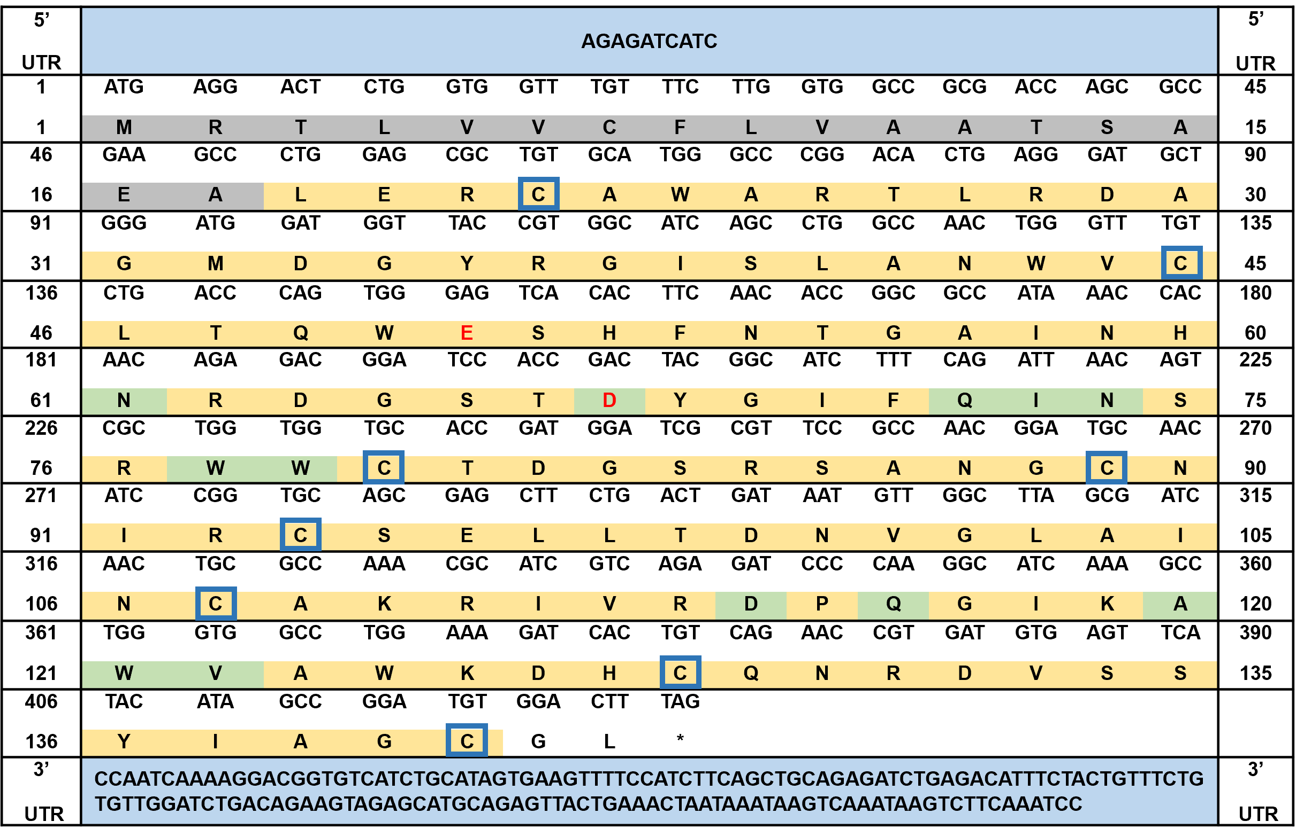
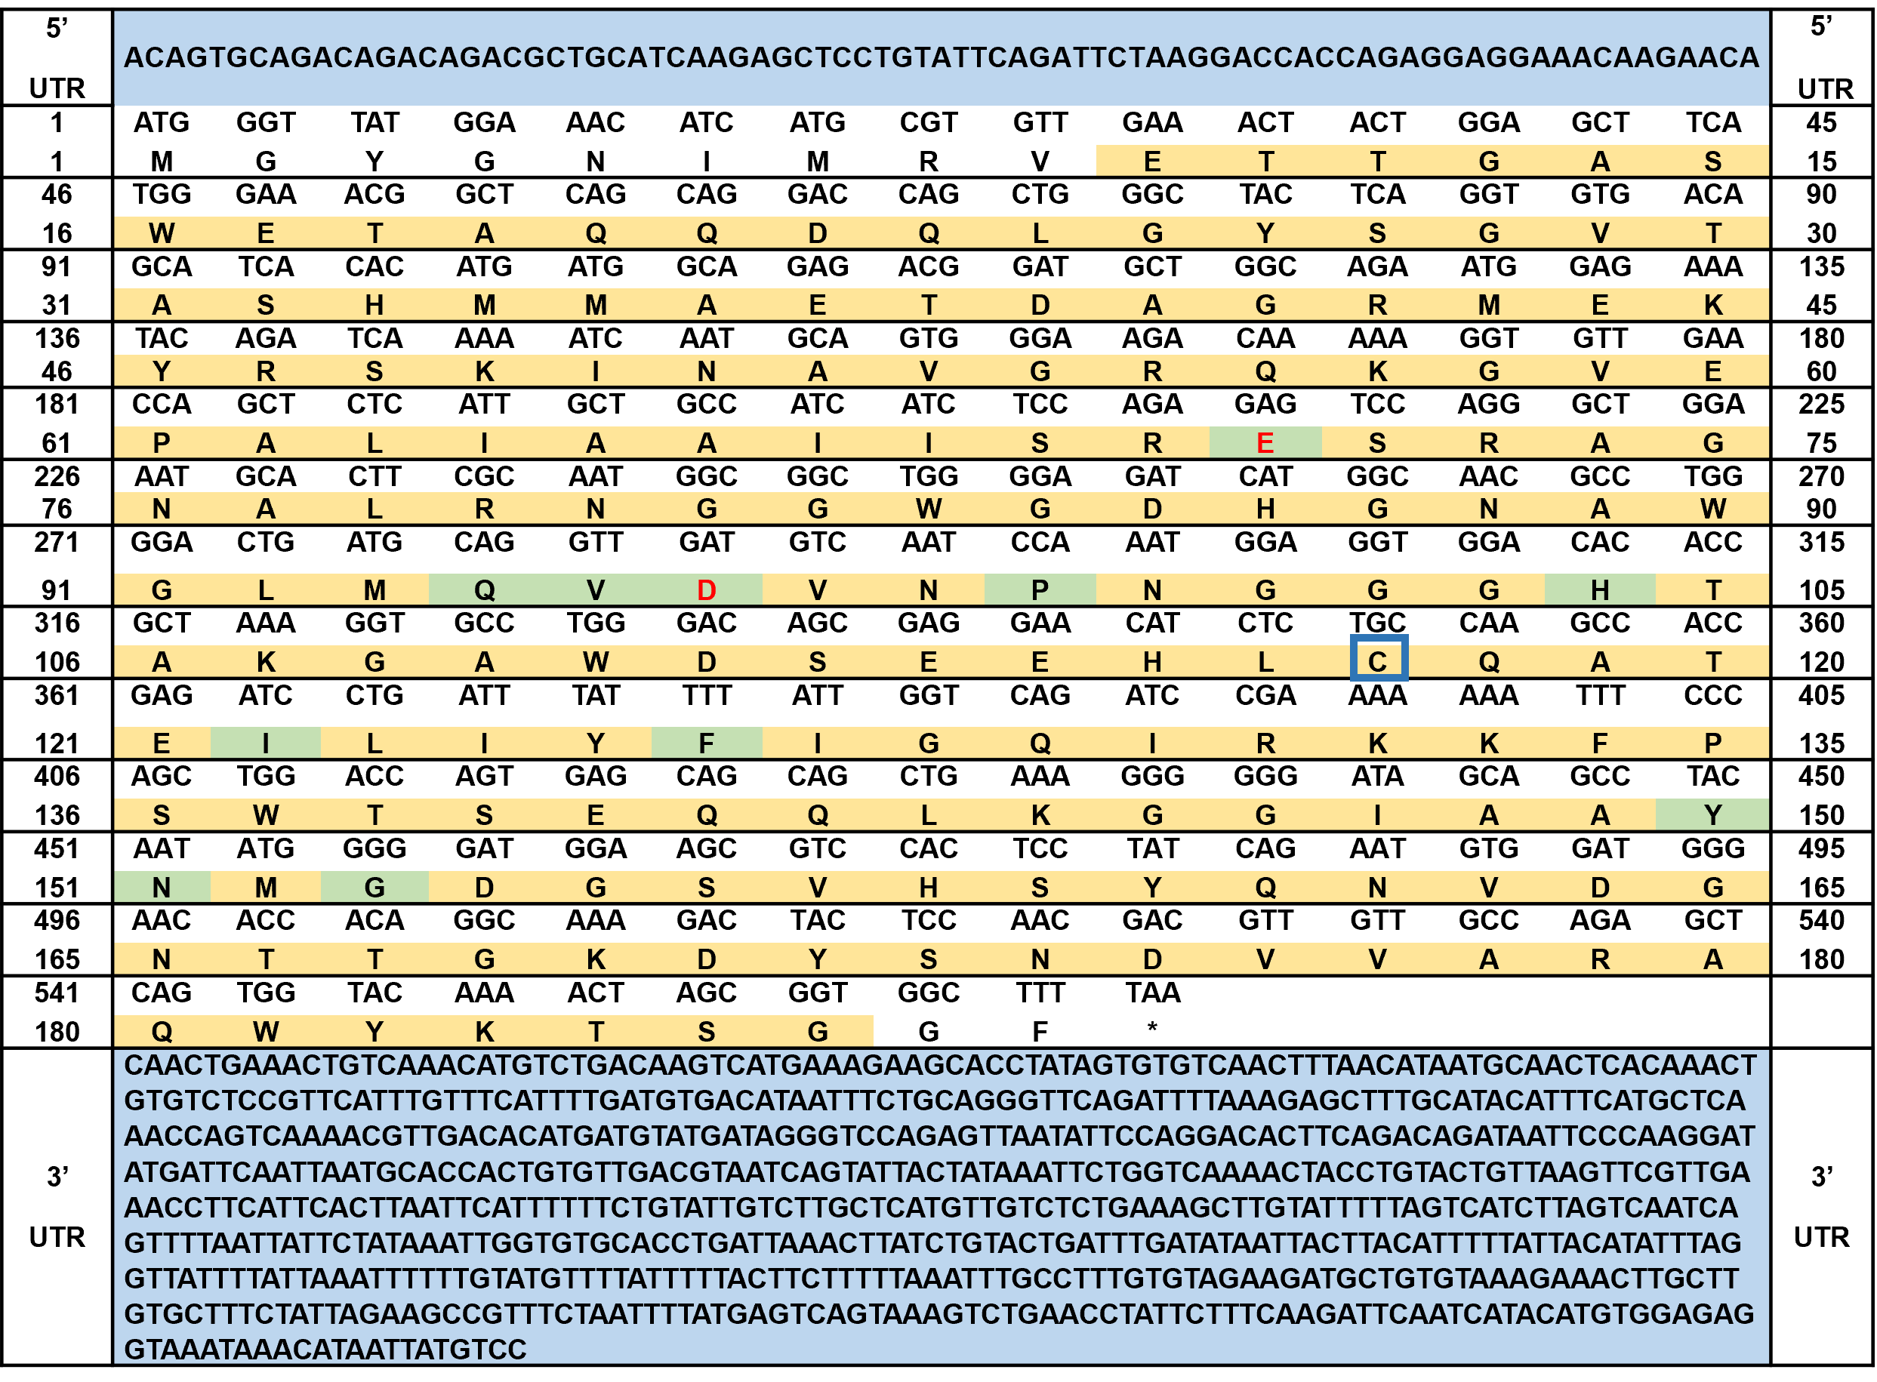
Fig. S1. Nucleotide and deduced amino acid sequences of (A) AcLysC and (B) AcLysG-like lysozymes. Signal peptide, open reading frame, and sugar-binding sites are shaded gray, yellow, and green, respectively. Cysteine residues are represented with blue boxes, and catalytic residues are represented with red letters.
A
B
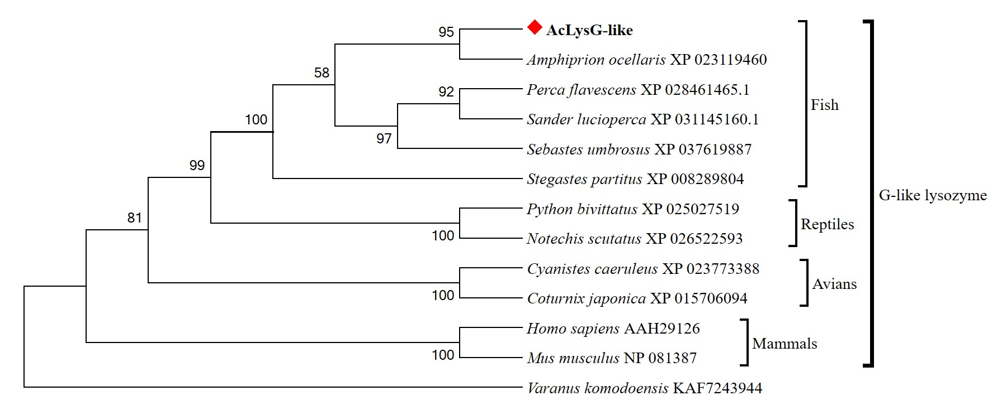
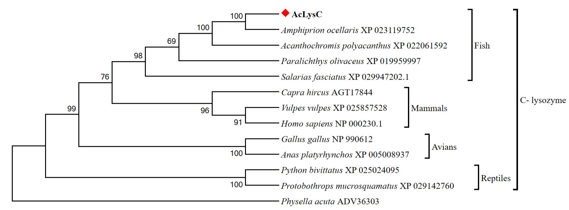
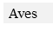
A
B
Fig. S2. Phylogenetic tree of (A) AcLysC and (B) AcLysG-like with other identified counterparts. The tree was constructed by MEGA version 6.0 with 5,000 bootstrap replicates under the neighbor-joining platform.

A
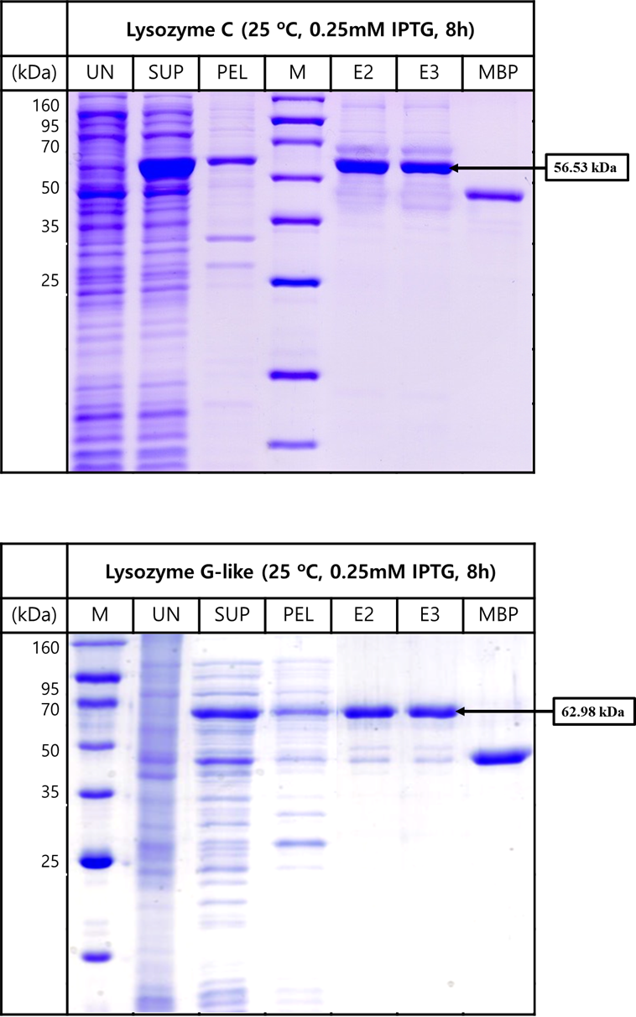
B
Fig. S3. Sodium dodecyl sulfate-polyacrylamide gel electrophoresis analysis of (A) AcLysC and (B) AcLysG-like recombinant proteins expressed in Escherichia coli ER2523 strain. Each lane indicates different stages of purification. UN, uninduced; SUP, Supernatant; PEL, Pellet; M, protein ladder; E2, second elution of protein; E3, third elution of protein; MBP, maltose-binding protein.

